**OCEANA COUNTY JUNIOR MARKET**

**EDUCATIONAL RECORD BOOK**

##### **Young Beef & Feeder Calf Project - 2023**

**(for ages 5-7)**

**If you are a little buddy check here: _____**

**My big buddy is: _________________________________________**

As a member of the Junior Market Animal Project, you are required to submit your records as part of an educational project notebook in order to show your animal at the Oceana County Fair. **This notebook must be shown to the Oceana County 4-H Market Livestock Committee's Weighmaster at the time of weigh-in and then entered by you in the Educational Notebook Division of the Oceana County Fair on Entry day.**

**AGE: _____**

**Number of years in project: _____**

**Remember:** The age you enter depends on how old you are or will be on January 1, 2023.

Use this sheet as the first page of your project record book. Fill it out completely.

**Please print or type neatly.**

NAME______________________________________________________________________________

4-H CLUB___________________________________________________________________________

BREED______________________________________ NAME_____________________________

ANIMAL DATE OF BIRTH____________________ DATE RECORD STARTED___________________

LOCATION OF WHERE ANIMAL IS RAISED _____________________________________________

**JUDGE’S SCORE/COMMENT SHEET**

**(PLEASE DO NOT REMOVE, PLACE THIS SHEET IN SHEET PROTECTOR OR GLUE TO COVER). This sheet must be keep free to the judge to write their comments.**

This sheet should help each junior market member understand their ribbon placing.

A. **Specific educational value or worth**

___ All questions were answered completely

___ All calculations were correct

___ Calculations were incorrect

___ Questions were not completely answered

___ Questions were not answered (missed questions)

B. **Notebook contains all project records**

___ Notebook contained all project records and were fully completed

___ Notebook contained additional project related information (research

materials etc.)

___ Project records were incomplete

___There was no additional project related information

C. **Accuracy, neatness and general appearance**

___Notebook was neat in appearance (typed/hand printed)

___ Notebook pages were clean and stain free

___Notebook pages were in order and complete

___Notebook pages were out of order and missing pages

___Notebook was difficult to read and messy

___Notebook had wrinkled and stained pages

Other Comments: __________________________________________________________________________

____________________________________________________________________________________________

____________________________________________________________________________________________

2023- Jr. Mkt Feeder/Young Beef Page 2

OBJECTIVES

1. Develop desirable work habits, sportsmanship, and ability to cooperate and express ideas through participation in projects, discussions, method demonstrations, judging teams, and exhibits.
2. Experience the pride and responsibility of leasing/owning and caring for beef.
3. Learn how to feed, fit, show, breed and raise beef.
4. Learn proper handling procedures to prevent injuries to members and their beef projects.
5. Appreciate and use scientific information in beef production and marketing.
6. Improve knowledge of grading, marketing and merchandising of beef products.
7. Learn the importance of the beef industry to the local, state, and national economies.
8. Acquire information on the opportunity that beef offers as a career.

This record book is part of your Junior Market Young Beef/Feeder Calf project. By keeping records up-to-date you will be able to see how much progress you make as you set goals and work to accomplish them. Write or type neatly and clearly. Please keep the pages in order. Feel free to add extra pages at the end of your notebook. Pictures are a required part of your notebook. Taking pictures of your project animal throughout the project will indicate how your animal has grown and developed. Add pictures to your notebook on a separate piece of paper.

***SCORING CRITERIA***

The following breakdown will be used during the judging process of all market livestock notebooks.

A. Specific educational value or worth **30%**

B. Creative way of showing what has been learned **10%**

C. Notebook contains all project records **50%**

#### D. Accuracy, neatness and general appearance **10%**

The Oceana County Agricultural Society encourages parent assistance with your project and project notebook. If you should have any questions, please contact the MSU Extension Office.

**If a parent or adult helped** you in filling out your notebook please have them sign below that the answers are YOUR answers and that they assisted you in the writing of the answers and understanding of the questions only.

__________________________________________________________________________________

(Signature of person helping with notebook)

___________________________________________________________________________________

(Printed name by member)

2023- Jr. Mkt Feeder/Young Beef Page 3

**ABOUT YOUR CALF**

My Calf’s name is: _______________________________________________________________

My Calf’s breed is: _______________________________________________________________

What color is your Calf? __________________________________________________________

My Calf’s favorite things to do is: _________________________________________________

__________________________________________________________________________________

**COLOR THE PICTURE- COLOR THE CALF TO LOOK LIKE YOURS**

2023- Jr. Mkt Feeder/Young Beef Page 4

**ANIMAL CARE AND MANAGEMENT- JOURNAL OF CARE**

Your project requires regular care and management. It is assumed that you helped walk & feed your animal but what additional things have you done?

Include the following:

* Feeding and watering practices
* Grooming (clipping, hoof trimming, washing, etc.)
* Health practices and medicines (vaccinations, etc.)
* General Management (cleaning living area, feed pans, etc.)

|  |
| --- |
| **Daily- Things done once or twice a day** |
|  |
| **Weekly- Things done once or twice a week** |
|  |
| **Monthly- Things done once a month** |
|  |
| **Yearly- Things done one time or occasionally throughout the year** |
|  |

2023- Jr. Mkt Feeder/Young Beef Page 5

**PROJECT INFORMATION**

The start of the project will be the date the exhibitor placed the animal on feed. The end of the project will be weigh-in at fair.

Project Start Date ___________________ Project End Date ___________________

What month was your calf born? _____________________________________

Please fill in the following information about your calf.

|  |  |  |  |  |  |  |  |
| --- | --- | --- | --- | --- | --- | --- | --- |
| **Calf’s Name** | **Calf’s RFID Number** | **Breed** | **Date of Purchase** | **Price or Value** | **Estimated Starting Weight** | **Ending Weight (may be estimated depending on Covid Restrictions)** | **Total Pounds Gained** |
|  |  |  |  |  |  |  |  |

**Note: Ending Weight-Starting Weight= Total Pounds Gained**

**MARKETING**

One of the most important parts of any market animal project is marketing. This may include writing letters and talking to prospective buyers. Color in the face, a smiling face is a good action; a frowning face is a bad action. (see the example)

**Good Marketing Practice Poor Marketing Practice**































Send a reminder to attend the auction

Send a picture to your potential buyer

Let and adult talk to the buyer instead of you talking to them

Know what kind of feed you used if asked

Only go to grocery stores or the banks

Only thank those who agree to be listed as a potential buyer

2023- Jr. Mkt Feeder/Young Beef PAGE 6

**(A.) MONTHLY FEED RECORD & EXPENSES**

***(have a parent, grandparent, older 4-H member, leader, etc. help you with this)***

|  |  |  |  |
| --- | --- | --- | --- |
| Month | Type of feed used | Lbs. of feed used for the month | Cost of feed used for the month |
| February |  |  |  |
|  |  |  |  |
| March |  |  |  |
|  |  |  |  |
| April |  |  |  |
|  |  |  |  |
|  |  |  |  |
| May |  |  |  |
|  |  |  |  |
|  |  |  |  |
| June |  |  |  |
|  |  |  |  |
|  |  |  |  |
| July |  |  |  |
|  |  |  |  |
|  |  |  |  |
| August |  |  |  |
|  |  |  |  |
|  |  |  |  |

**(A) Total Cost of Feed**  **$__________________________**

2023- Jr. Mkt Feeder/Young Beef PAGE 7

**(B) OTHER PROJECT EXPENSES**

|  |  |  |
| --- | --- | --- |
| **DATE** | **VET, BEDDING, EQUIPMENT, TRUCKING, CLIPPING, MARKETING/BUYER RECOGNITION, ETC.** | **COST** |
|  |  | **$** |
|  |  |  |
|  |  |  |
|  |  |  |
|  |  |  |
|  |  |  |
|  |  |  |
|  |  |  |
|  | **(B) TOTAL SPENT ON OTHER EXPENSES** | **$** |

**(C)** **COST OF FEEDER CALF**  **$**_____________

**TOTAL EXPENSES (A+B+C) = $ __________ (TE)**

**_______________ ÷ _________________ = ___________________________________________**

Total Expenses **(TE)** Final Weight **(FW)** Break Even Price **(BE)**

(*or* total cost per pound to raise your animal)

***+ Final weight may be estimated depending on Covid restrictions in Summer 2021***

***\*\* Have your parent, leader or an older teen in your club help you figure out your breakeven price. The breakeven price is the price that you need to get at the Junior Market animal auction in order to not lose money on your market project. \*\****

2023- Jr. Mkt Feeder/Young Beef Page 8

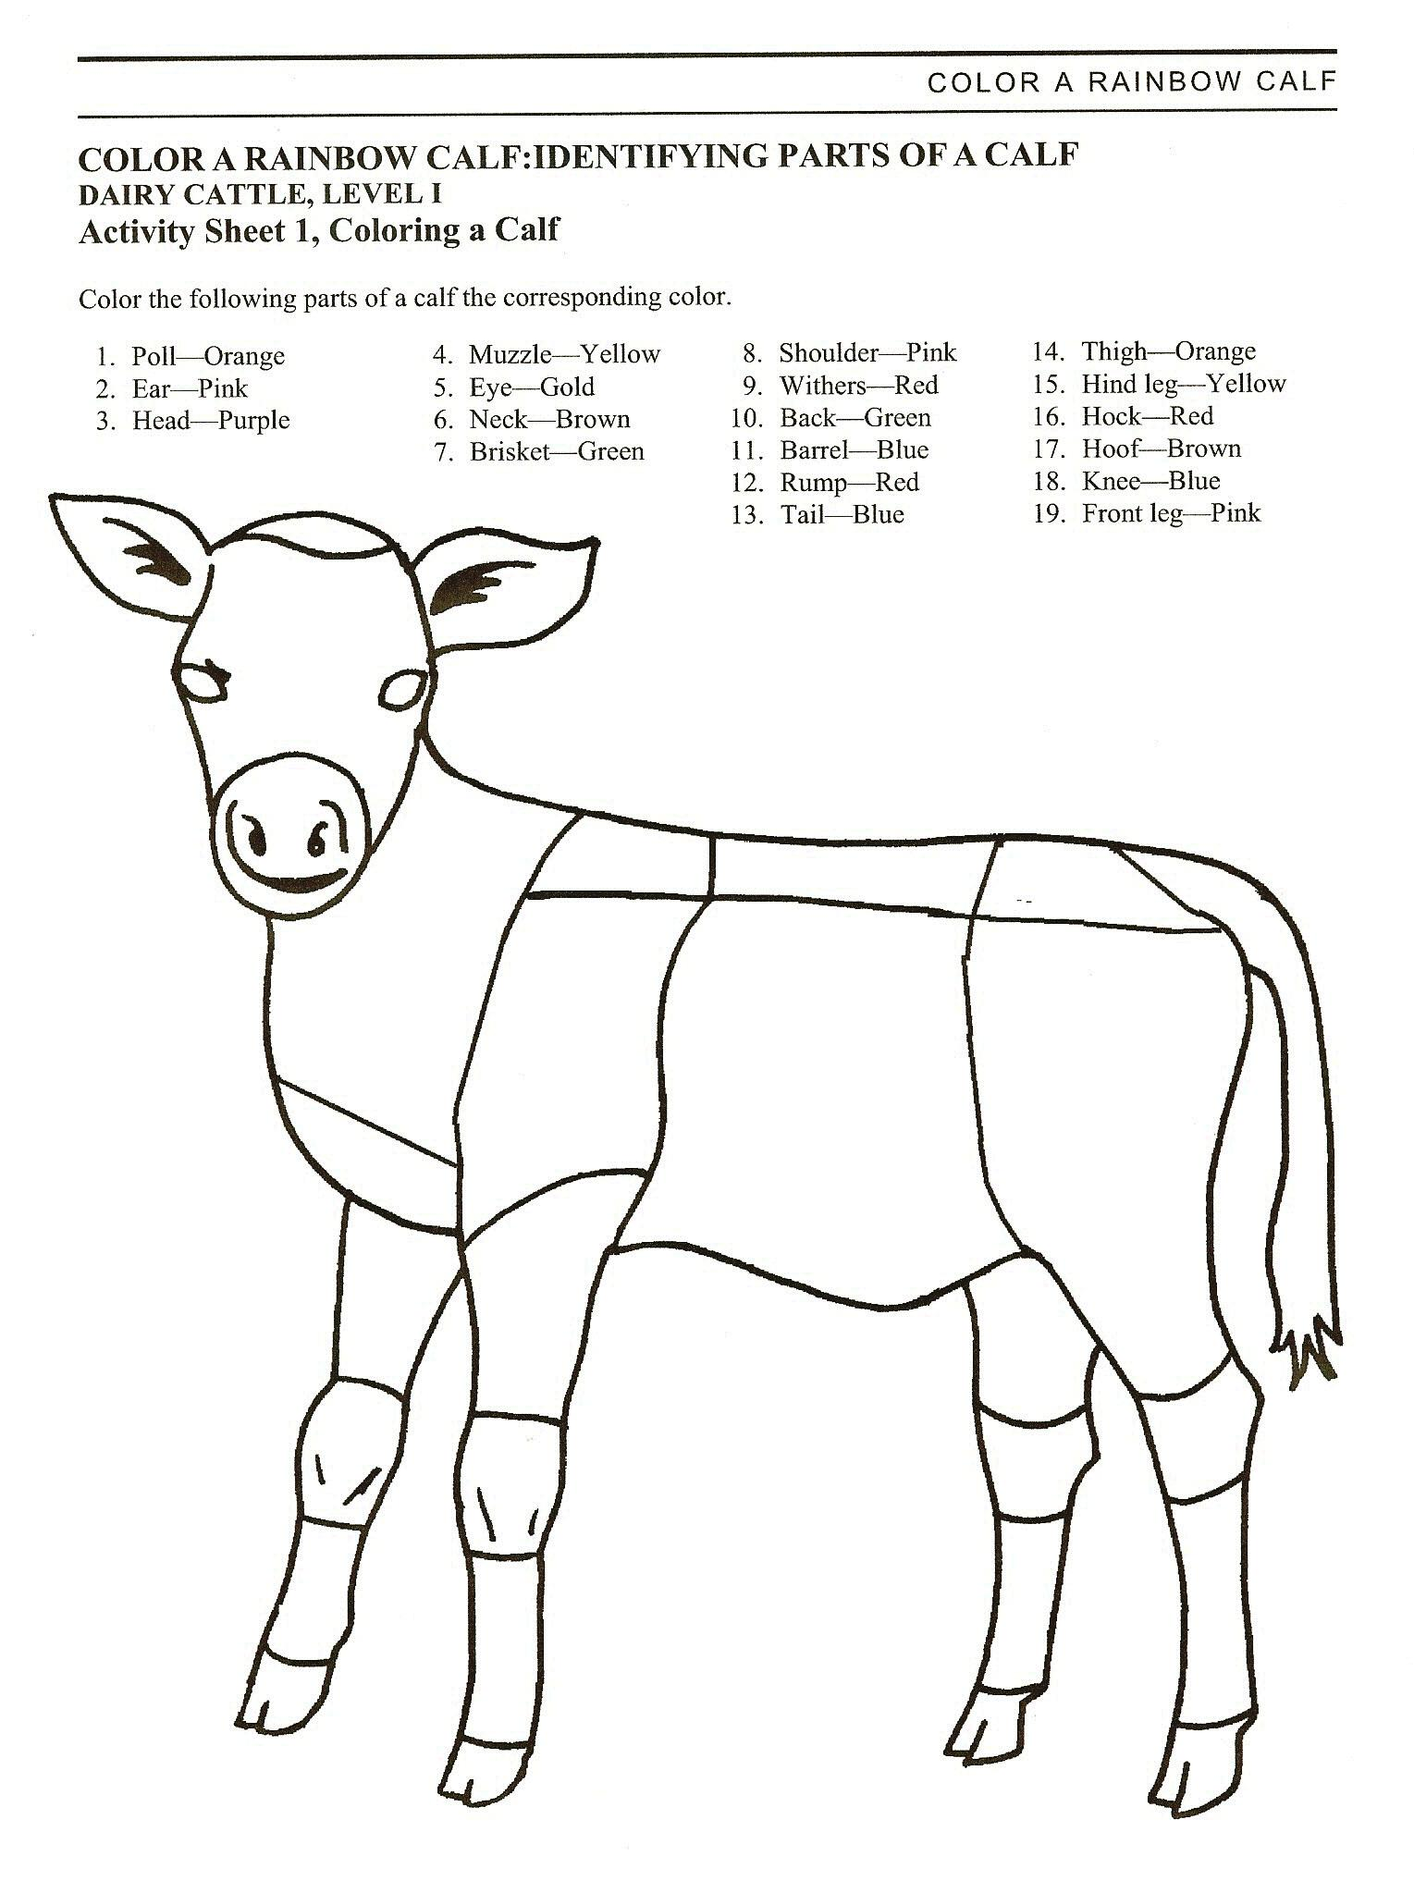

Courtesy of Kansas State University, Beef Leader Notebook

2023- Jr. Mkt Feeder/Young Beef Page 9

**WHAT DOES YOUR CALF NEED?**

(have an adult help you read the following - then **circle those items that your calf** needs below)

All living creatures need certain things to survive, like *food*, *water* and shelter. *Farmers* take care of their animals to make sure they are healthy and comfortable. If any animals are sick the farmer will treat them with the help of the *veterinarian.* The vet may give them immunizations to prevent them from becoming sick.

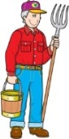 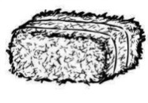  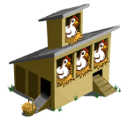 

FARMER MOLDY HAY ICE CREAM COOP WATER

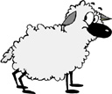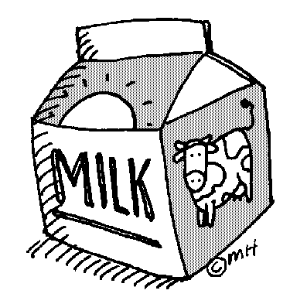

BARN

FARMER

BIKE

JUICE

WATER

CLOTHES

MILK

CORN

VETERINARIAN

TV

CAKE

 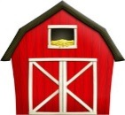  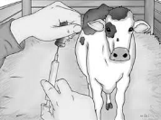  VETERINARIAN BARN/SHELTER CAKE VACCINATIONS GRASS

**IDENTIFY GOOD AND BAD CHARACTER ACTIONS**

Color in the face, a smiling face = a good action; a frowning face = a bad action.

**RAISING and SHOWING an RAISING and SHOWING an**

**ANIMAL *with* CHARACTER ANIMAL *without* CHARACTER**

Feed animals on time

Complain about the judge

Clean stalls daily

Thank the Judges for their time

Congratulate whoever places first

Ask for help

Leave animals outside without shelter

Have an adult complete you notebook for you



































2023- Jr. Mkt Feeder/Young Beef Page 10

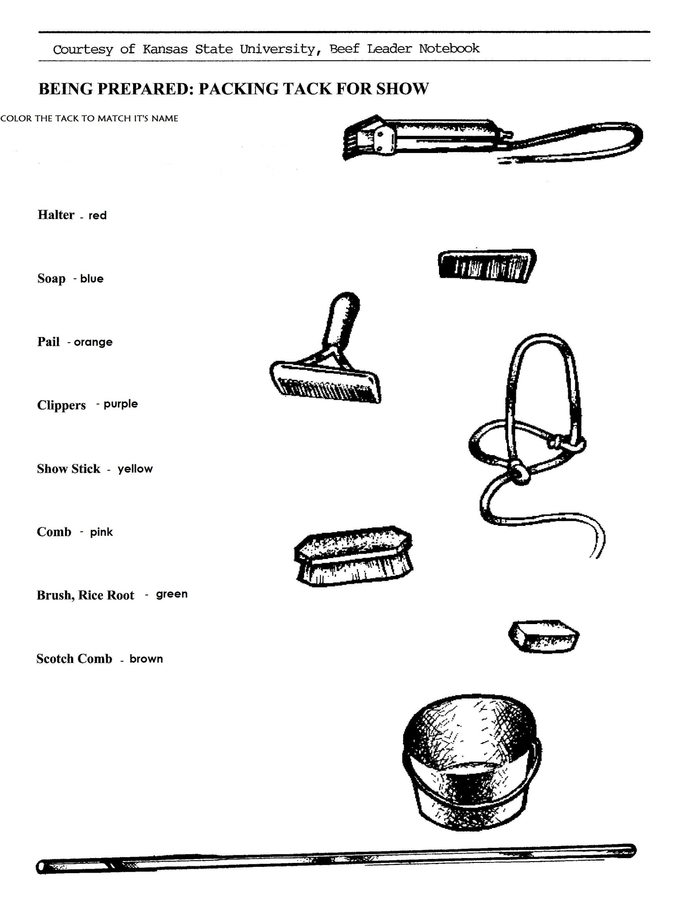

BRUSH, RICE ROOT- BLUE

CLIPPERS-RED

SOAP- PURPLE

COMB-YELLOW

HALTER- GREEN

PAIL- ORANGE

SHOW STICK- PINK

SCOTCH COMB- BLACK

2023- Jr. Mkt Feeder/Young Beef Page11

**ANSWER THE FOLLOWING QUESTIONS:**

**(the judge wants the answer in *YOUR* words, even if someone helped with the printing)**

1. What did you have the most fun doing with your project?

____________________________________________________________________________________

____________________________________________________________________________________

___________________________________________________________________________________

____________________________________________________________________________________

___________________________________________________________________________________

____________________________________________________________________________________

1. What was the hardest part of your project?

___________________________________________________________________________________

____________________________________________________________________________________

____________________________________________________________________________________

____________________________________________________________________________________

___________________________________________________________________________________

____________________________________________________________________________________

2023- Jr. Mkt Feeder/Young Beef Page 12

**4-H KNOWLEDGE**

**The 4-H Pledge**- *Draw a line to the picture that fills in the blank* (see the example)

***I pledge…***

HANDS

HEALTH

HEAD

HEART

WORLD

COUNTRY

CLUB

COMMUNITY

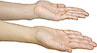









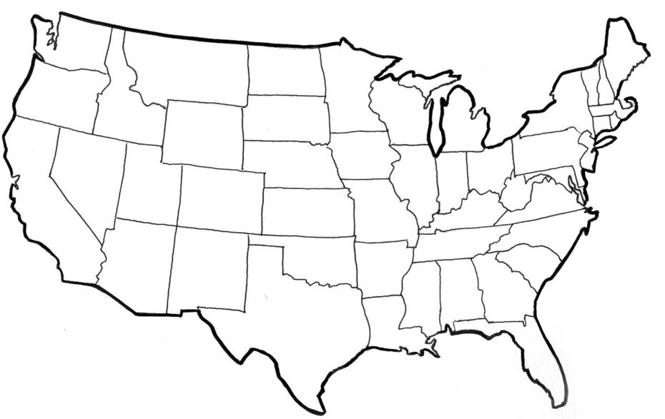





My ____________ to clearer thinking,

My ____________ to greater loyalty,

My ____________ to larger service, and

My _____________ to better living,

for my ____________________,

my _______________________,

my _______________________,

and my ____________________.

Number of club meetings held: **__________** Number you attended: **_________**

2023- Jr. Mkt Feeder/Young Beef Page 13

**SHOWMANSHIP - TRUE OR FALSE (circle T for true or F for false)**

1. You should ***relax and enjoy*** showing, do not overshow the animal, T F

as you are showing the animal, not yourself?

2. You should tie the halter around your hand when leading your calf? T F

3. Tennis shoes are okay to wear when working with your calf? T F

4. You should move around the calf in a circle as the judge is viewing it? T F

5. You lead your calf from the left side when showing and walk T F

in a clockwise direction?

6. You should tell the judge “thank you for your time” even if you don’t T F

agree with him or her?

7. You must have your stalls clean by 10:00 a.m. every day during Fair? T F

8. As you are a “cloverbud” you must have an adult, or older 4-Her,

holding the lead with you? T F

***POTENTIAL BUYERS NAMES***

As part of your 4-H Small Market Livestock Project, you must personally contact at least three potential buyers before the Oceana County Fair. You are encouraged to seek two new buyers that have not been asked or submitted before. **You also must have at least three different buyers than those of your siblings in the market livestock project.** Please confirm with your buyers their accurate mailing address (example: post office box vs. a street address). The information on page 14 must be completed and taken to the Oceana County MSU Extension Office on or before the due date where it will be **copied** and used to send out letters to your potential buyers. This page will remain in your notebooks. This is a Market Livestock Committee rule. Failure to comply will result in not being able to sell your animal in the 4-H Market Livestock Sale.

2023- Jr. Mkt Feeder/Young Beef Staff ____________

Page 14 Date ____________

**JUNIOR MARKET/SMALL MARKET POTENTIAL BUYER’S LIST**

**FEEDER CALF PROJECT (AGES 5-7)**

Name______________________________ Club_________________________

***Please print business names and complete addresses clearly.***

* 1. Contact Name ________________________________________________­­____

Business Name ____________________________________________________

**Mailing** Address _________________________City__­­­­­­­­__­­­­­­­_____________Zip_____

Phone _______________________ After Hours Phone______________________

Mailing Preference (Please Check One): Email ____ Postal Delivery ____

Email ____________________________________________________________

Signature__________________________________________________________

2. Contact Name ________________________________________________­­____

Business Name ____________________________________________________

**Mailing** Address _________________________City__­­­­­­­­__­­­­­­­_____________Zip_____

Phone _______________________ After Hours Phone______________________

Mailing Preference (Please Check One): Email ____ Postal Delivery ____

Email ____________________________________________________________

Signature__________________________________________________________

3. Contact Name ________________________________________________­­____

Business Name ____________________________________________________

**Mailing** Address _________________________City__­­­­­­­­__­­­­­­­_____________Zip_____

Phone _______________________ After Hours Phone______________________

Mailing Preference (Please Check One): Email ____ Postal Delivery ____

Email ____________________________________________________________

Signature__________________________________________________________

(Must be stamped by the MSU Extension Office)

2023- Jr. Mkt Young Beef and Feeder Calf Page 15

**PICTURES OF YOUR PROJECT**

(Please use this page for your project pictures. Add additional pages if you would like. The judges appreciate you labeling the pictures so they know what the picture shows.)

***NON-CLUB* POINTS- JUNIOR/SMALL MARKET PROJECT**

***(This must be filled out by participant before presenting for signatures at the MSUE office)***

|  |  |  |  |  |
| --- | --- | --- | --- | --- |
| **MEETING NAME** | **LOCATION** | **DATE** | **POINTS** | **SIGNATURE OF LEADER, SUPERINTENDENT OR MSU STAFF** |
|  |  |  |  |  |
|  |  |  |  |  |
|  |  |  |  |  |
|  |  |  |  |  |
|  |  |  |  |  |
|  |  |  |  |  |
|  |  |  |  |  |
|  |  |  |  |  |
|  |  |  |  |  |
|  |  |  |  |  |

Please note: This form must be included with your record notebook and turned into the weigh master on entry day of the Fair. **BEFORE SEEKING SIGNATURES AT MSU EXTENSION – MEETING NAME AND DATE MUST BE COMPLETED** You need to accumulate **nine (9) points** to be allowed to sell your animal. **Six (6)** of these **nine (9) points** must come from club meetings. The **three (3)** non-club points must be earned from attending various 4-H events and activities. See your leader, the MSUE office, or online at <https://www.canr.msu.edu/oceana/oceana_county_4_h/oceana_4_h_market_livestock> for a listing of approved nonclub points.

**JUNIOR/SMALL MARKET PROJECT CLUB POINTS**

***(This must be filled out by participant before presenting for signatures at the MSUE office)***

|  |  |  |  |  |
| --- | --- | --- | --- | --- |
| **MEETING NAME** | **LOCATION** | **DATE** | **POINTS** | **SIGNATURE OF LEADER, SUPERINTENDENT OR MSU STAFF** |
|  |  |  |  |  |
|  |  |  |  |  |
|  |  |  |  |  |
|  |  |  |  |  |
|  |  |  |  |  |
|  |  |  |  |  |
|  |  |  |  |  |
|  |  |  |  |  |
|  |  |  |  |  |
|  |  |  |  |  |
|  |  |  |  |  |

Please note: This form must be included with your record notebook and turned into the weigh master on entry day of the Fair. You need to accumulate **nine (9) points** to be allowed to sell your animal. **Six (6)** of these **nine (9) points** must come from club meetings. The **three (3)** non-club points must be earned from attending various 4-H events and activities